GATE 0 - PROJECT SYNOPSIS
Themes 1-5 | System / Tool / Engine based Mini Projects

Expected length: about 4 pages + cover page
Team No. | 10
Theme No. | 4
Project Title | Dependency Aware Parallel Build System
Guide Name | Dheeraj Kumar sir
Team Members | 1.Nilaksha Nath  2.Sunayana Kamath  3.Bachu Venkata Siva Jaideep  4.Prathamesh Eedigi

Student Preparation Instruction
This synopsis is intended to demonstrate the team's own understanding of the proposed project. Students should study the project, discuss within the team, consult relevant textbooks/technical resources, and prepare the content in their own words. AI tools shall not be used to generate the contents of this document.
At Gate 0, do NOT finalize: detailed functional/non-functional requirements, architecture/modules, algorithms/data structures, APIs, technology stack, alternate designs, detailed KPIs or test cases.
1. Background & Motivation
Briefly describe the proposed system/tool/engine, its purpose, broad functionalities/computational capabilities, and why developing it is technically meaningful as a Mini Project. Highlight opportunities to apply and integrate foundational Computer Science concepts.
The proposed project is a dependency-aware parallel build system that manages software build or computational tasks according to their dependencies. It represents tasks as a directed acyclic graph (DAG), identifies tasks that are ready to execute, and allows independent tasks to run in parallel. The system also avoids unnecessary repeated work when inputs have not changed by maintaining persistent task state. The project is technically meaningful because it combines process management, concurrency, graph-based dependency reasoning, persistent state and parallel execution in one practical systems problem.

2. Project Objectives
State 3-5 broad engineering objectives. Describe what the team intends to develop or study. Do not prematurely prescribe architecture, algorithms, data structures, APIs or implementation mechanisms.
1. Develop a system that represents task dependencies and manages their execution in the correct order.
2. Enable independent tasks to execute in parallel while respecting their dependencies.
3. Reduce unnecessary repeated work by identifying unchanged tasks between executions.
4. Maintain task execution state so that build activity can be observed and evaluated.
5. Evaluate the system using controlled workloads to study correctness and parallel execution performance.

FOUNDATION COURSE INTEGRATION & CONCEPTUAL VIEW
Gate 0 - Themes 1-5

3. Foundation Course Integration
Identify at least three foundational courses that are expected to contribute meaningful technical depth. Mention only broad concepts/areas at this stage.
Sl. No. | Foundation Course | Broad Concepts / Areas Expected to be Applied | Role
1 | Operating Systems | Process management, concurrency, child processes | Dominant
2 | DAA / DMS | Graphs, DAGs, traversal, dependency reasoning | Dominant
3 | DBMS | Persistent state and stored task information | Supporting
4 | Parallel Computing | Task parallelism, speedup and efficiency | Dominant
4. Conceptual Workflow / System View
Draw one high-level block/workflow diagram showing the broad functional flow or major interactions in the proposed artefact. Keep it conceptual; detailed architecture, finalized modules, algorithms, data structures, APIs and technologies belong to later stages.
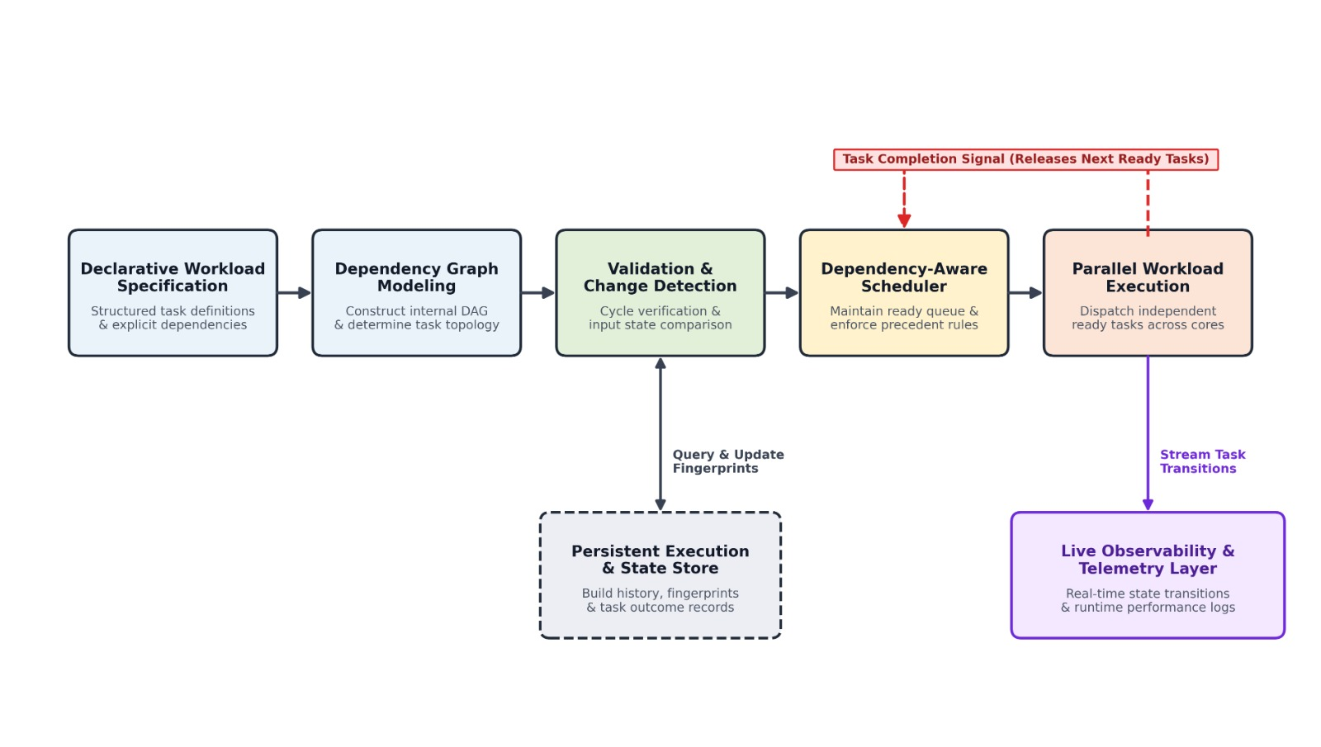
Insert / draw conceptual workflow or system view here

SCOPE & FEASIBILITY
Gate 0 - Themes 1-5

5. Broad Project Scope
Define the tentative technical boundary of the project. Detailed requirements will be derived later in S1.
5.1 Broadly In Scope
# | Broad In-Scope Item
1 | Task and dependency specification for build or computational workloads
2 | Dependency-aware execution with safe ordering of tasks
3 | Parallel execution of independent ready tasks
4 | Persistent change detection and task-state tracking
5.2 Out of Scope
# | Out-of-Scope Item | Reason
1 | OS kernel modification or compiler implementation | The project is limited to a user-space build/task engine.
2 | Distributed multi-machine or cloud execution | The initial project focuses on controlled local multi-core execution.
3 | Full enterprise build-system replacement or hardware changes | These are beyond the academic mini-project scope and timeline.
6. Feasibility & Constraints
Briefly assess whether the proposed scope is achievable as a 3-credit Mini Project. Identify required resources, prerequisite knowledge and major constraints. Existing libraries/tools may support peripheral functionality but should not completely hide the core mechanisms students are expected to design, implement and study.
Feasibility within 3-credit scope | Achievable when the core engine, dependency handling, parallel execution and persistent state are prioritized.
Required computing / resources | A multi-core development PC/laptop, Python environment and local persistent storage.
Prerequisite knowledge | Operating Systems, graphs/DAGs, concurrency, databases, software engineering and parallel computing.
Major constraints / limitations | 15-week academic timeline; performance depends on hardware and workload; scope must be controlled.
Use of existing libraries / tools | Python standard libraries and supporting tools can provide process, file, hashing, database and testing support while the core scheduling logic remains student-designed.
Overall feasibility | Feasible with scope modification

INITIAL PROJECT RISKS & FACULTY REVIEW
Gate 0 - Themes 1-5

7. Initial Project Risks
Identify 2-3 major risks that may affect completion of the project and briefly state how the team plans to address them. These are initial risks and may be revised as the project evolves.
Sl. No. | Possible Risk | How will you address it?
1 | Dependency or scheduling errors | Validate dependency relationships and test execution order with controlled task graphs.
2 | Concurrency or race-related issues | Use bounded parallel execution and test task-state transitions carefully.
3 | Cache invalidation or repeated-work errors | Track relevant input changes and update persistent state only after successful execution.
. Gate 0 - Faculty Review
☐ Technical motivation and objectives are clear.
☐ At least three foundation courses show potential for meaningful technical depth.
☐ Conceptual workflow/system view clearly communicates the proposed artefact.
☐ Broad scope is appropriate for a 3-credit Mini Project.
☐ Core mechanisms can be designed/implemented rather than fully hidden by ready-made tools.
☐ Feasibility, constraints and initial risks are reasonably identified.
Decision: ☐ Approved ☐ Approved with Modifications ☐ Resubmit
Faculty Remarks:
________________________________________________________________________________
________________________________________________________________________________
________________________________________________________________________________
Guide Signature: ____________________________ Date: __________________

